CANCLED

The City of Dubuque Community Development Advisory Commission will meet on Wednesday, April 24, 2018 at 5:30 p.m. in the, Housing & Community Development Conference Room, Suite 312 on Third Floor of the Historic Federal Building, 350 West 6th Street, Dubuque, Iowa

Agenda

- Oath(s) of Office
- Call to Order/Meeting Certification
- Approval of Meeting Minutes, Wednesday, March 28, 2018
- Correspondence/Public Input

At this time anyone may address the Commission on matters which are of concern to them and which are not an agenda item. Reminder: No formal or official action may be taken at this time on public comments because of the notice requirements of the Iowa Open Meeting Law.

This notice is given pursuant to Chapter 21, The Code of Iowa, and applicable regulations of the City of Dubuque. Visual or hearing-impaired persons needing special assistance should contact the Housing and Community Development Department at (563) 589-4239: (563) 589-4230 for TDD.

- Communication from Craig Beytien regarding Rental Rehabilitation Program
- Communication from Julita Schneider, Davis Place, regarding financial hardship for affordable housing providers resulting from bed bug infestation

- Old Business
- Applications for Community Development Block Grant Funding
- Visiting Nurses Association requests to present at the May Meeting
- City Manager’s message on grants

- New business
- Large Neighborhood Grant Recommendations
- Set Public Hearing FY 17 CAPER
- Responding to Identified Community Needs
- Review Proposed Rental Rehabilitation Program
- Technical Assistance for Small Business, Women’s Business Factory

- Reports
- Housing Commission Report
- Resiliency Commission Report
- Housing & Community Development Report
- Neighborhood Report
- Information Sharing
- Adjournment
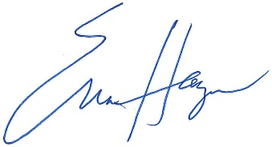

Erica Haugen, Community Development Specialist

