The City of Dubuque COMMUNITY DEVELOPMENT ADVISORY COMMISSION will meet on Wednesday, March 28, 2018 at 5:30 p.m. in the, Housing & Community Development Conference Room, Suite 312 on Third Floor of the Historic Federal Building, 350 West 6th Street, Dubuque, Iowa
Agenda
- Oath(s) of Office
- Call to Order/Meeting Certification
- Approval of Meeting Minutes, January 17, 2018
- Correspondence/Public Input

At this time anyone may address the Commission on matters which are of concern to them and which are not an agenda item. Reminder: No formal or official action may be taken at this time on public comments because of the notice requirements of the Iowa Open Meeting Law.

This notice is given pursuant to Chapter 21, The Code of Iowa, and applicable regulations of the City of Dubuque. Visual or hearing-impaired persons needing special assistance should contact the Housing and Community Development Department at (563) 589-4329: (563) 589-4230 for TDD.

- Communication from Mary Parkin to request Commission consider providing technical assistance to low and moderate income individuals wishing to start a business or eligible business owners wanting to expand an existing business.

Old Business
  - Applications for Community Development Block Grant Funding
    - Crescent Community Health Center
    - Visiting Nurses Association
    - Proposed Annual Action Plan Amendment

New business
- Set Public Hearing FY 17 CAPER
- Proposed Rental Rehabilitation Program
- City Manager’s Message on Grants
- Large Neighborhood Grants

Reports

Housing Commission Report

Resiliency Commission Report

Housing & Community Development Report

Federal Budget Update

Neighborhood Report

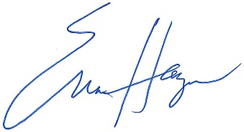
Information Sharing

Adjournment

Erica Haugen, CDBG/HCV Supervisor
Housing and Community Development Department

