

OFFICIAL MEETING AGENDA

The City of Dubuque COMMUNITY DEVELOPMENT ADVISORY COMMISSION scheduled for Wednesday February 17th at 5:30 p.m. has been CANCELED.

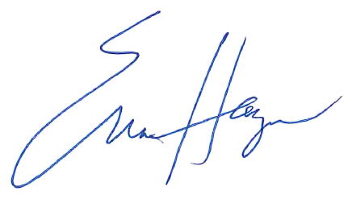

Erica Haugen, Community Development Specialist Housing and Community Development Department

